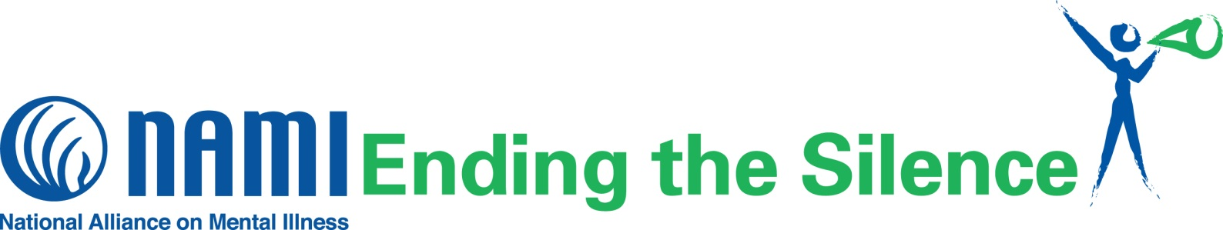

**What is NAMI Ending the Silence?**

NAMI Ending the Silence is a free presentation designed to give audience members an opportunity to learn about mental illness through an informative Power Point and short videos. There are three types of Ending the Silence presentations: one for Students, one for School Staff, and one for Families. Each presentation outlines symptoms of mental health conditions and gives attendees ideas about how to help themselves, friends, or family members who may need support. Additionally, all 3 presentations include personal testimony from a young adult living with a mental health condition and his/her journey to recovery.

NAMI Franklin County, the local organization of the National Alliance on Mental Illness, now offers the NAMI Ending the Silence presentation via Zoom.

**Audience Perspectives**



**Contact us to schedule a NAMI Ending the Silence presentation for your school or organization!**

“I’m really grateful and glad that you talked to us. I often feel very alone or weird because many kids my age don’t understand. But, now I’m sure they would be more supportive of me.” -Student

“It is amazing what just one day, one talk can do. You never really know what’s going on in the brain of any particular student.” -Teacher



**About NAMI**

NAMI, the National Alliance on Mental Illness, is the nation’s largest grassroots mental health organization dedicated to building better lives for the millions of Americans affected by mental illness. NAMI Franklin County is an affiliate of NAMI Ohio. NAMI Franklin County and dedicated volunteer members and leaders work tirelessly to raise awareness and provide essential education, advocacy and support group programs for people in our community living with mental illness and their loved ones.

**Contact Name: Jeff Thompson**

**NAMI Franklin County**

**1225 Dublin Rd., Suite 050**

**Columbus, Ohio 43215**

**(614) 501-6264**

[**jeff@namifc.org**](mailto:jeff@namifc.org)

[**www.namifranklincoynty.org**](http://www.namifranklincoynty.org)

**{NAMI Affiliate Email}**