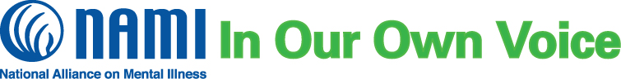

**What is NAMI In Our Own Voice?**

NAMI In Our Own Voice is an interactive presentation that provides insight into what it’s like to live with mental illness. The presentation is led by two adults living with mental health conditions and includes video and discussion. Audiences are given a safe place to ask questions and gain understanding of an often misunderstood topic. Through dialogue, we help grow the movement to build better lives.

NAMI Franklin County, the local organization of the National Alliance on Mental Illness, will offer its next NAMI In Our Own Voice presentation upon your request.

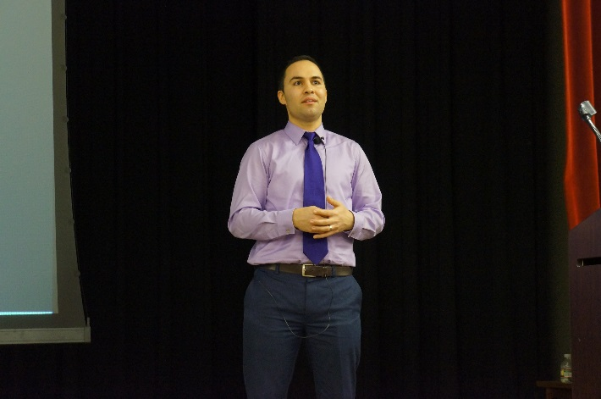

**Audience Perspectives**

“I learned more about mental health conditions from these generous people than any book I have read.”

“The presenters were fantastic and I’m lucky to have heard them speak. They had great energy and empowerment!”

**Contact us to schedule a NAMI In Our Own Voice presentation for your organization!**

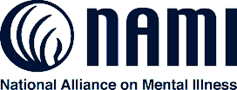

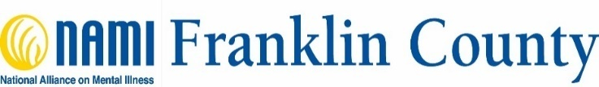

**About NAMI**

NAMI, the National Alliance on Mental Illness, is the nation’s largest grassroots mental health organization dedicated to building better lives for the millions of Americans affected by mental illness. NAMI {Affiliate Name} is an affiliate of NAMI {State}. NAMI {Affiliate Name} and dedicated volunteer members and leaders work tirelessly to raise awareness and provide essential education, advocacy and support group programs for people in our community living with mental illness and their loved ones.

**Laurita Barber**

**NAMI Franklin County**

**1225 Dublin Rd., Suite 050**

**Columbus, Ohio 43215**

**(614) 530-4554**

[**laurita@namifc.org**](mailto:laurita@namifc.org)

[**www.namifranklincounty.org**](http://www.namifranklincounty.org)