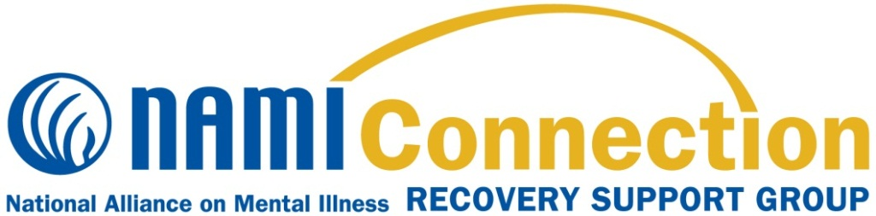

**What is the NAMI Connection Recovery Support Group Program?**

NAMI Connection is a recovery support group program that offers respect, understanding, encouragement and hope. NAMI Connection groups are:

* Free and confidential
* Held weekly for 90 minutes
* Designed to connect, encourage, and support participants using a structured support group model
* Led by trained facilitators living in recovery themselves

NAMI Franklin County, the local organization of the National Alliance on Mental Illness, offers a NAMI Connection Recovery Support every Monday, Thursday and Saturday. The in-person group is held every Monday from 6:30 pm – 8:00 pm at New Birth Christian Ministries located at 3475 Refugee Rd., Columbus, Ohio 43232 in room 209. Thursdays Zoom group meets from 6:30 pm – 8:00 pm and Saturday Zoom group meets from 12 noon – 1:30 pm. The Meeting ID for each group is 824-479-7473, the password is 6145016264.

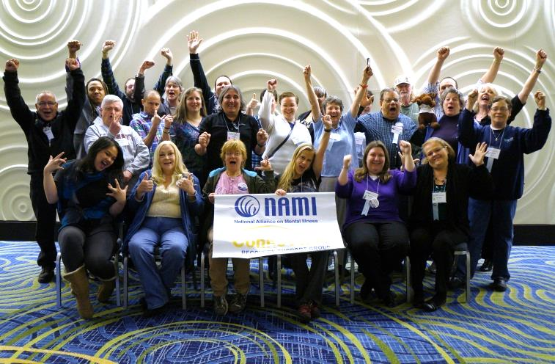

**Participant Perspectives**

“NAMI Connection has made me realize that I can truly feel comfortable around my peers and I really needed that feeling!”

“I believe NAMI Connection means hope.”

“NAMI Connection is the promise of what is and what can be in our lives.”

**Contact us to find out more about NAMI Connection Recovery Support Groups! Program!**

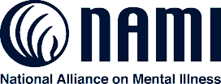

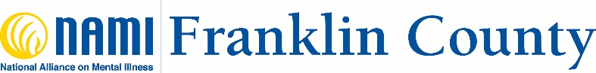

**About NAMI**

NAMI, the National Alliance on Mental Illness, is the nation’s largest grassroots mental health organization dedicated to building better lives for the millions of Americans affected by mental illness. NAMI Franklin County is an affiliate of NAMI Ohio. NAMI Franklin County and dedicated volunteer members and leaders work tirelessly to raise awareness and provide essential education, advocacy and support group programs for people in our community living with mental illness and their loved ones.

**Regina Hillman**

**NAMI Franklin County**

**1225 Dublin Rd., Suite 110**

**Columbus, Ohio 43215**

**614-501-6264**

**regina@namifc.org**

**www.namifranklincounty.org**